חלופה מערכות הגנת סייבר במקצוע "תכנון ותכנות מערכות" - הערכה לעבודת גמר 5) יחידות לימוד( – תשפ"ו

332091636 | מספר ת.ז. | שלומי לוי | שם התלמיד
RemotedCar |  |  | נושא העבודה
25.05.2026 | תאריך ההגשה | נטליה ששוב | שם המנחה

Revision History

Ed. Id | Date | Reason for Change
1 |  | Baseline

Contents
1. Introduction 2
1.1 System Overview 2
1.2 Related software or hardware 2
1.3 End-user characteristics 2
1.4 General Constraints 3
1.5 System Architecture - Functionality 3
1.5.1 Subsystem Architecture 4
1.5.2 DB tables 5
1.5.3 Protocol 6
1.5.4 Encription 6
1.5.5 Classes 6
1.6 System Architecture - Presentation Layer 7
1.6.1 Forms workflow 7
1.7 Source Code 7
1.8 SW Test plan 8
1.8.1 Test scenarios 8
1.8.2 Test Results 8
2. Bibliography 8

Introduction
This file designed to be an intro for my project RemotedCar which is a project that you have 2 clients 1 to install in the car and 1 as an app in the mobile or a web page, in the app you need to login to use your other unit you installed in the car which then you can control varies things in it such as air conditioning if its locked or unlocked windows or even lookup where is your car even when you are very far from it to have an easier time if you forgot something about you car or just want to arrive to a chill cabin in a hot day.

System Overview
The project will have 2 clients and 1 server one client will be on the web which will be called “the user” the user will have functions that was previously assigned by the physical options on the other client which will be called “the controller” which seats in the car and connected to its components,
the user will be provided with a login screen first of all and after they login they will have to register the controller to their account(pin and id on the physical board or something to identify) if its not already assigned to someone(the checks will be on the server side for security reasons) after that the user will have a token generated and saved in the server database with date which will provide a solution if someone account got stolen and saved on someone else’s device the user will have the ability to remove all tokens from the database in order to disconnect all the connected users after that the user will be able to trigger some signals in the controller communicating through the server to finally communicate with the car the communications will be like that
web → rest api + websocket(for live responses)
controller → socket(tcp)

Related software or hardware
Spy spot - https://spy-spot.com
volvo digital key - https://www.volvocars.com/en-ca/support/car/ex90/article/47d2c97fd33effd3c0a8cc3718c999b7-05c7943009a1cf5bc0a8b09752cce648-8664b2fa77a7e089c0a8296870d1a409/

End-user characteristics
Any person with a car and available sim card network nearby

General Constraints
Server – any operating system that can run python 3.10 (Eg. linux, windows,mac os)
Client web – browser supporting javascript fetch and cookies
Client car module – Arduino Uno the code is written for the chip “atmega328p”by default you but can tweak the code for any board supporting:
- tcp connection
- rom >= 1 kbytes
- ram >= 2 kbytes
- flash(storing the program) >= 32 kbytes

System Architecture – Functionality
The server controls the connections between all of the clients more mostly from user web client to a controller where the server has a rest api side serving a website and has a “socket” side using tcp serving the controllers while also using a database in the background to handle users logic and saving commands for the controllers to run
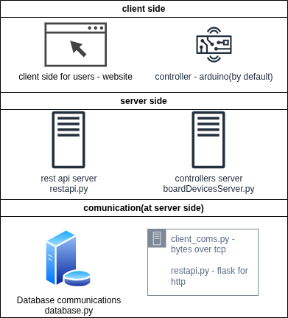

Subsystem Architecture

Use Case – 1st…
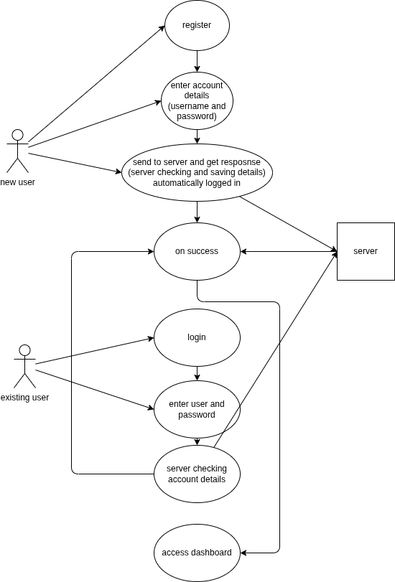

Use Case – 2nd
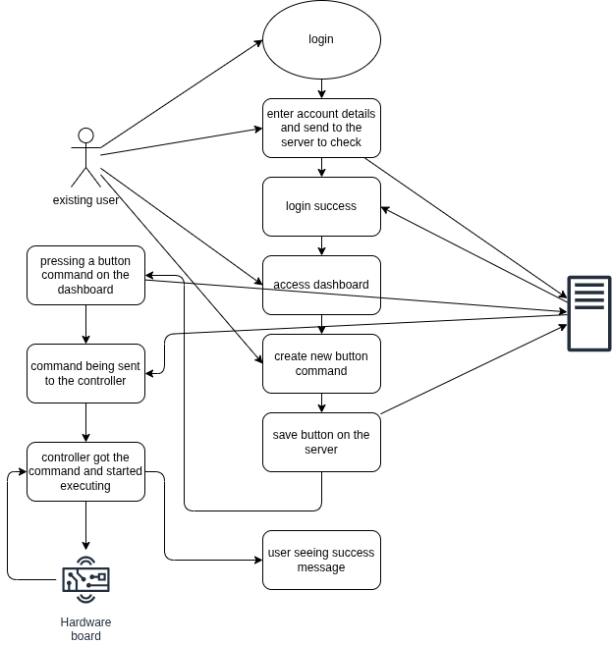

Sequence diagram – 1st…

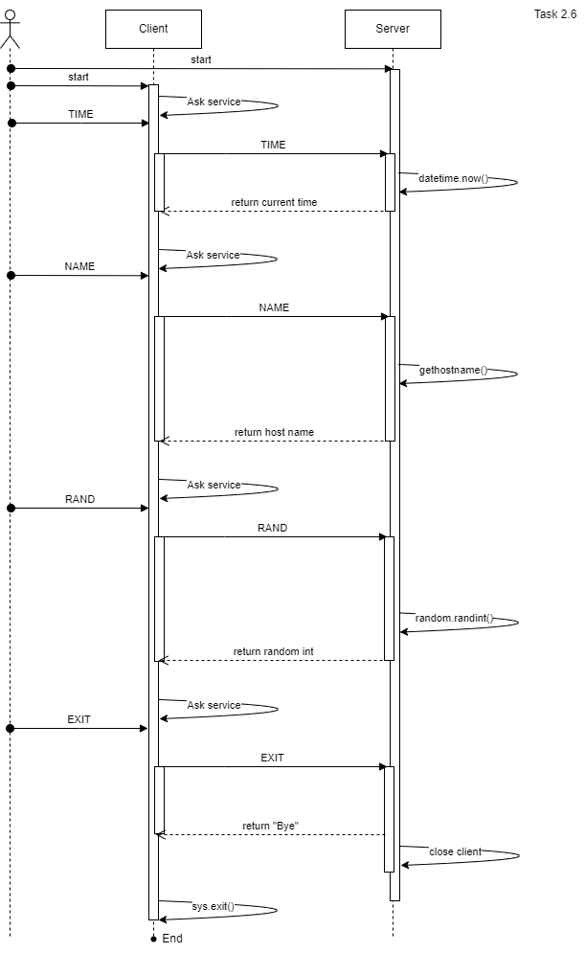

Sequence diagram – 2nd…
…

DB tables
…
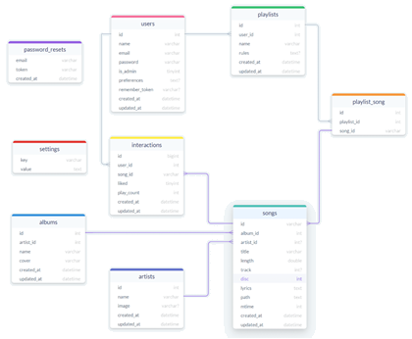

Protocol
Full msg length
header_size = 4
header_size = 4
header_size = 4
header_size = 4
header_size = 4
Type length
Key1 length
Key2 length
Value1 length
Full msg length | Type length | Type | Key1 length | Key1 | Value1 length | Value1 | Key2 length | Key2 | ...
The message is built dynamically based on the number of arguments,
built from a json like object first the whole message with maximum value size 2^(header_size*8) which is defaulted to 4 bytes now,
then calculates the whole message size and put it as a number in front of the message

Encription
…

Classes
…
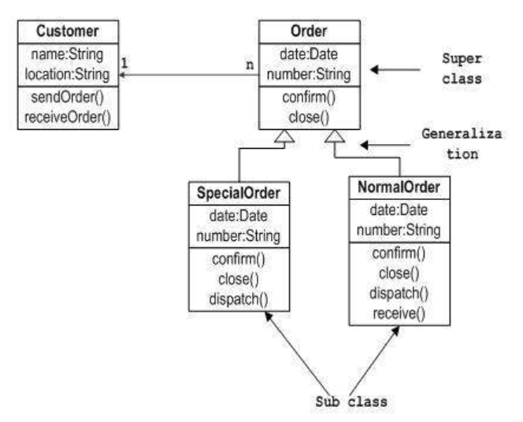…

System Architecture - Presentation Layer
…

Forms workflow
…
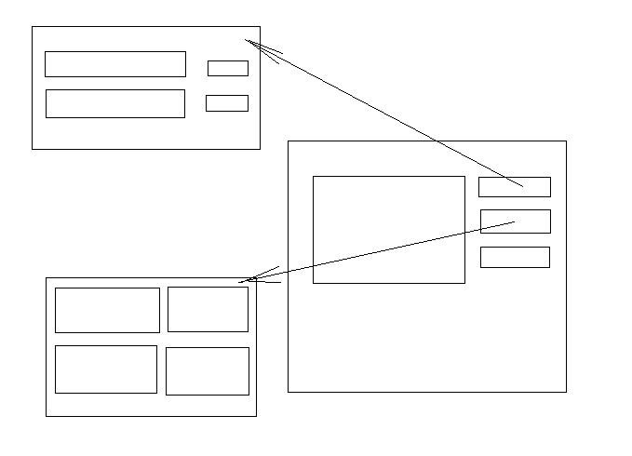…

Source Code
…

SW Test plan
…

Test scenarios
…

Test Results
…

Bibliography

